Perancangan Smart Server System Berbasis Monitoring

Suhu, Kelembapan, dan Keamanan Akses di CV Gundara

Solusi Bersama Ungaran

Aizaas Vianansa Rochmawan¹, Priyadi², Candra Supriadi³
^{1,2,3}Program Studi S1 Sistem Komputer, Universitas Sains dan Teknologi Komputer Semarang
Email author: aizaasvianansa@gmail.com, Second Author2, Third Author3

Article Info |  | ABSTRACT
Article history:  Received March 1, 2026  Revised April 17, 2026  Accepted May 28, 2026 |  | The main problem of server rack management at CV Gundara Solusi Bersama Ungaran is the absence of automatic temperature and humidity monitoring as well as physical access security. The reliance on room ambient cooling without rack-level sensor monitoring risks overheating and hardware damage. Additionally, the conventional key-based door lock provides no access logging, violating the CIA Triad (Confidentiality, Integrity, Availability) principles. This research designs and implements a Smart Server System using the ESP32 microcontroller integrated with an SHT21 temperature and humidity sensor, a 4x4 Keypad, a 4-Channel Relay, two DC cooling fans, a Solenoid Door Lock, an LCD 20x4 I2C display, and a Web Dashboard with Google Sheets cloud logging. The system automatically activates cooling fans when temperature exceeds 27°C and unlocks the door only upon verified PIN input, logging all access events and sensor data to Google Sheets via HTTPS REST API. The Research and Development (R&D) method with iterative prototyping was used. The system is expected to achieve sensor reading accuracy with a Mean Absolute Error (MAE) below 0.5°C, system response time under 5 seconds, and 100% access event logging with 99% system uptime. This system offers an affordable and scalable IoT solution for IT infrastructure management applicable to small and medium enterprises (SMEs) in Indonesia.
Keywords:
Access Control
ESP32
IoT Monitoring
SHT21 Sensor
Smart Server System
Corresponding Author:
Aizaas Vianansa Rochmawan,
Universitas Sains dan Teknologi Komputer
Jl. Majapahit No. 605 Semarang
Email: join@stekom.ac.id


PENDAHULUAN
Infrastruktur rak server pada perusahaan yang bergantung pada layanan teknologi informasi menuntut standar operasional yang ketat guna menjamin ketersediaan layanan secara berkelanjutan. Standar Telecommunications Industry Association TIA-942 menetapkan bahwa lingkungan pusat data harus mempertahankan suhu antara 18°C hingga 27°C dengan kelembapan relatif maksimum 70% RH untuk menjaga integritas dan umur pakai komponen perangkat keras [1]. Kegagalan mempertahankan parameter lingkungan tersebut dapat mempercepat degradasi komponen dan mengurangi keandalan server secara signifikan [2]. Menurut kajian terbaru, panas berlebih merupakan penyebab utama kegagalan perangkat keras server, menyumbang hingga 55% dari total kerusakan komponen elektronik [3].
CV Gundara Solusi Bersama merupakan National Strategic Executor yang menangani lebih dari 1.200 proyek infrastruktur telekomunikasi untuk klien strategis nasional seperti PLN Icon+ dan MKON. Kondisi rak server aktual di lokasi tersebut, sebagaimana ditunjukkan pada Gambar 1, memperlihatkan kepadatan kabel dan perangkat yang tinggi tanpa sistem pemantauan suhu otomatis. Pendinginan sepenuhnya bergantung pada AC ruangan yang tidak mampu mendeteksi hotspot lokal di dalam rak. Selain itu, akses pintu server masih menggunakan kunci konvensional tanpa pencatatan, melanggar prinsip CIA Triad—Confidentiality, Integrity, dan Availability [8].
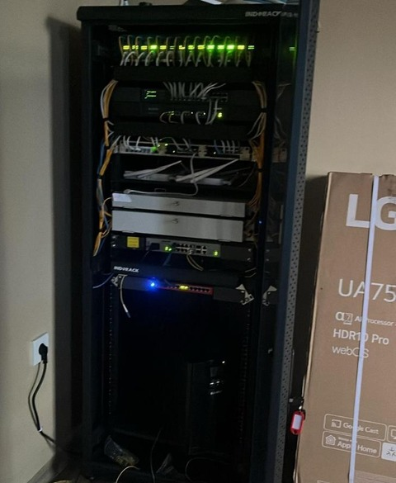
Gambar 1. Kondisi Rak Server di CV Gundara Solusi Bersama (Sumber: Data Peneliti, 2026)
Berbagai penelitian sebelumnya telah mengkaji pengelolaan termal server dari sudut pandang yang berbeda-beda. Wan et al. [1] mengembangkan sistem pendinginan tingkat rak berbasis deep reinforcement learning. Gul dan Eroglu [4] mengimplementasikan jaringan sensor IoT berbasis ESP32 berbiaya rendah untuk pemantauan kualitas udara real-time. Cho dan Lim [3] menemukan sensor tingkat rak dapat mengurangi hotspot hingga 40%. Wan et al. [5] mengembangkan SafeCool berbasis model reinforcement learning. Qu et al. [6] melakukan tinjauan komprehensif pemantauan suhu IoT pada sistem kritis. Yusof et al. [7] membahas REST API aman menggunakan enkripsi simetris. Namun, penelitian-penelitian tersebut berfokus pada aspek termal saja tanpa mengintegrasikan kontrol akses fisik, atau menggunakan algoritma kompleks yang tidak sesuai untuk usaha mikro, kecil, dan menengah (UME).
Berdasarkan kajian literatur tersebut, terdapat kesenjangan: belum ada sistem yang mengintegrasikan manajemen termal otomatis, kontrol akses fisik elektronik, dan pencatatan audit berbasis cloud dalam satu platform IoT terjangkau untuk konteks UME Indonesia. Penelitian ini bertujuan mengisi kesenjangan tersebut dengan merancang Smart Server System berbasis ESP32 yang memenuhi ketiga aspek sekaligus, diimplementasikan pada rak server CV Gundara Solusi Bersama Ungaran.

METODE
Penelitian ini menggunakan metode Research and Development (R&D) dengan model prototyping iteratif. Pendekatan ini terbukti efektif untuk memvalidasi dan menyempurnakan sistem hardware-software terintegrasi secara bertahap [9]. Proses pengembangan mencakup delapan tahap: (1) analisis kebutuhan, (2) desain prototipe, (3) evaluasi desain, (4) implementasi hardware-software, (5) unit testing, (6) integration testing, (7) field testing di CV Gundara, dan (8) finalisasi dokumentasi. Iterasi dilakukan pada setiap tahap hingga kriteria kualitas terpenuhi sebelum melanjutkan ke tahap berikutnya.
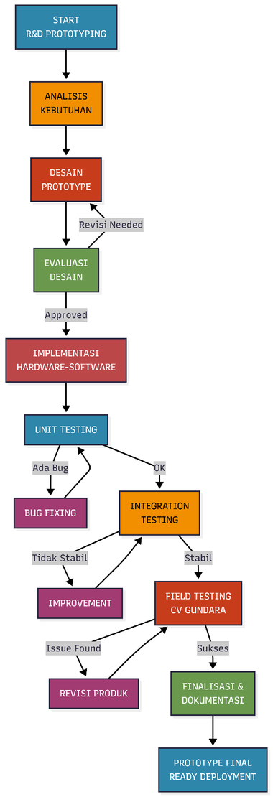
Gambar 2. Diagram Model Pengembangan R&D Iteratif (Sumber: Data Peneliti, 2026)

Arsitektur Sistem
Sistem menggunakan ESP32 Development Board sebagai unit pemroses utama, dipilih berdasarkan kemampuan dual-core Xtensa LX6 berkecepatan hingga 240 MHz, Wi-Fi terintegrasi 802.11 b/g/n, dan dukungan GPIO yang lengkap [11]. Diagram blok arsitektur sistem ditunjukkan pada Gambar 3, yang memperlihatkan integrasi tiga subsistem fungsional: (1) manajemen termal melalui sensor SHT21 dan kipas pendingin DC via Relay, (2) keamanan akses fisik melalui Keypad 4x4 dan Solenoid Door Lock, serta (3) pencatatan data dan pemantauan melalui Google Sheets cloud dan Web Dashboard.
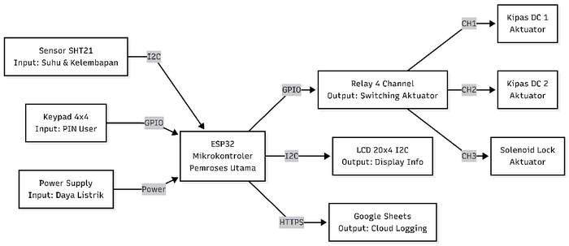
Gambar 3. Diagram Blok Smart Server System (Sumber: Data Peneliti, 2026)

Komponen Hardware dan Wiring
Sensor SHT21 (Sensirion, CMOSens®) mengukur suhu dan kelembapan secara presisi via I2C, beroperasi pada 2,1V–3,6V dengan konsumsi arus 300 µA saat pengukuran [12]. Keypad Matrix 4x4 menggunakan arsitektur pemindaian matriks yang hanya membutuhkan 8 pin GPIO [13]. Solenoid Door Lock beroperasi pada 12V DC dengan gaya tarik minimum 50 gram-force, waktu aktivasi maksimum 10 detik [14]. Kipas pendingin Brushless DC (BLDC) memberikan efisiensi energi dan durabilitas tinggi [15]. LCD 20x4 I2C menampilkan status sistem secara lokal [16]. Implementasi wiring lengkap seluruh komponen ditunjukkan pada Gambar 4. Konfigurasi pin detail disajikan pada Tabel 1.
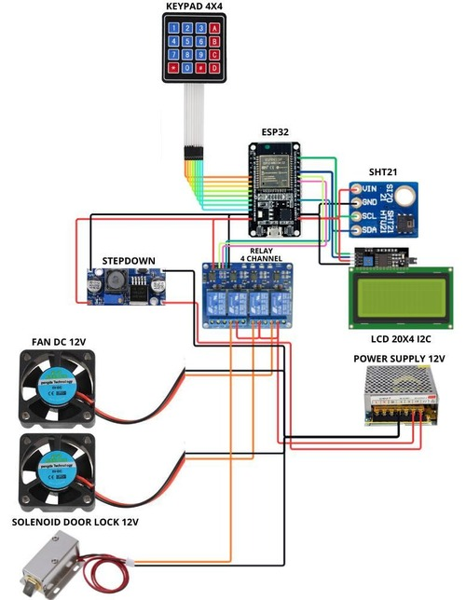
Gambar 4. Wiring Smart Server System (Sumber: Data Peneliti, 2026)


Figure 1. KOMPAK template

Table 1. Summary of Tips & Tricks for a good Scientific Article
Content | Should be Fulfilled | Checklist
Title | - Maximum 15 words  - Explicitly contains PMR (Problem, Method, and Result, for example: "Automatic Text Summary using Deep Learning for Indonesian Language Documents")  - Does not contain Locus (Case studies or locations that are too specific, for example: in SMA XX)  - Does not contain words such as: Overview/brief/Introduction, Review, Case study/Study, Survey, Approach, Comparative, Analysis, Comparative Investigation, Investigation | ✓
Abstract | - Maximum 250 words.  - To the point explicitly explains: objectives, methodology, and results, may add a little contribution/implication.  - May not contain citations. | ✓
Keywords | - Consists of 3-5 keywords that are easy to find on the Google search engine.  - In alphabetical order.  - It is highly recommended that keywords be adjusted to the title | ✓
Introduction | At least 3 paragraphs containing: (1) Paragraph I contain the background/problems/facts that support the research/study; (2) Paragraph II contains the state of the art/related works which contains at least 5 related previous studies; (3) Paragraph III contains the research position/gap/differentiation and defines the purpose of the research/study. | ✓
Methodology | - Explicitly explain whether qualitative/quantitative/mix method/other specific methods/algorithms used in the research.  - Describe the case study and data sources (data collections) used | ✓
Result and Discussion | - Written systematically according to the method used  - Completely explain the results of the research  - In the discussion there must be references cited as a comparison/analysis of the linkages of the findings with previous research | ✓
Conclusion | - Do not repeat the abstract  - Contains results and discussion (findings), contributions, implications, can also explain the "lack of study" of the research.  - There should be suggestions for further research | ✓
References | - Minimum 20 references  - 80% are sourced from reputable journal articles (clear sources and DOI) up to date, maximum in the last 5 years  - 20% comes from sources other than journal articles (books, news portals, etc.)  - Using the Mendeley reference manager | ✓

- RESULT DAN ANALISIS (10 PT)

In this section, it is explained the results of research and at the same time is given
the comprehensive discussion. Results can be presented in figures, graphs, tables and others that make
the reader understand easily [14], [15]. The discussion can be made in several sub-sections.

3.1. Sub section 1
Equations should be placed at the center of the line and provided consecutively with equation numbers in parentheses flushed to the right margin, as in (1). The use of Microsoft Equation Editor or MathType is preferred.

$E_{v}-E=\frac{h}{2.m} (k_{x}^{2}+k_{y}^{2}$) (1)

All symbols that have been used in the equations should be defined in the following text.

3.2. Sub section 2
Proper citation of other works should be made to avoid plagiarism. When referring to a reference item, please use the reference number as in [16] or [17] for multiple references. The use of ”Ref [18]...” should be employed for any reference citation at the beginning of sentence. For any reference with more than 3 or more authors, only the first author is to be written followed by et al. (e.g. in [19]). Examples of reference items of different categories shown in the References section. Each item in the references section should be typed using 8 pt font size [20]–[25].

3.2.1. Subsub section 1
Lorem ipsum

3.2.2. Subsub section 2
Lorem ipsum

- DISCUSSION/CONCLUSION (10 PT)

Provide a statement that what is expected, as stated in the "Introduction" chapter can ultimately result in "Results and Discussion" chapter, so there is compatibility. Moreover, it can also be added the prospect of the development of research results and application prospects of further studies into the next (based on result and discussion).

ACKNOWLEDGEMENTS (10 PT)
This research was supported/partially supported by [Name of Foundation, Grant maker, Donor]. We thank our colleagues from [Name of the supporting institution] who provided insight and expertise that greatly assisted the research, although they may not agree with all of the interpretations/conclusions of this paper.

REFERENCES (10 PT)
APA Style Seventh Edition Template: This Is Just an Example Title

Ajournalarticle, R. H., Spud, P. T., & Psychologist, R. M. (2016). Title of journal article (not the title of the journal) goes here. Journal of Research in Personality, 22(3), 236-252. doi:10.1016/0032-026X.56.6.895*
B’Journalarticlewithnodoi, S. O. (2020). Include issue numbers after volume numbers and note where italics start and stop. Journal of Articles Without Digital Object Identifiers, 127(3), 816-826.
Cmagazinearticle, B. E. (2009, July 24). Note that each source type has to be formatted in a different way. Prose Magazine. https://prosemag.org/2009/07/24/note-that.shtml
Dbookreference, S. M., Orman, T. P., & Carey, R. (1967). Google scholar’s “cite” feature is usually accurate and time-saving, so use it. Dre’s Publishing House.
Echapter, P. R., & Inaneditedvolume, J. C. (2022). Science shows frustration with giant style manuals. In P. Z. Harris, R. O. Dawkins, & J. H. Dennett (Eds.), Research papers are hard work but are good for you (2nd ed., pp. 123-256). Simon & Schuster.
Fonlinenewsarticle, M. (1994, September 11). This is how you cite an online news article that has an author. Vox. Retrieved from https://www.vox.com/notreal/just-an-example
* In APA style, including a DOI is required for all publications that have a DOI. This means you can skip the inclusion of a DOI if you’ve earnestly looked, but can’t find any DOI. See https://apastyle.apa.org/ for many more rules about references. Footnotes like this aren’t appropriate in a real references section.
NOMENKLATUR
Nomenklatur disertai arti dari semua persamaan matematika ataupun nomenklatur lain di alam artikel, dituliskan pada bagian ini.

❒ arti dari 
E arti dari variabel E
J_{c} arti dari variabel J_{c}

